# Implementation

## 2D Array

self.win is a 2D array that holds the players cards and hand strength in order to find the winning hands.

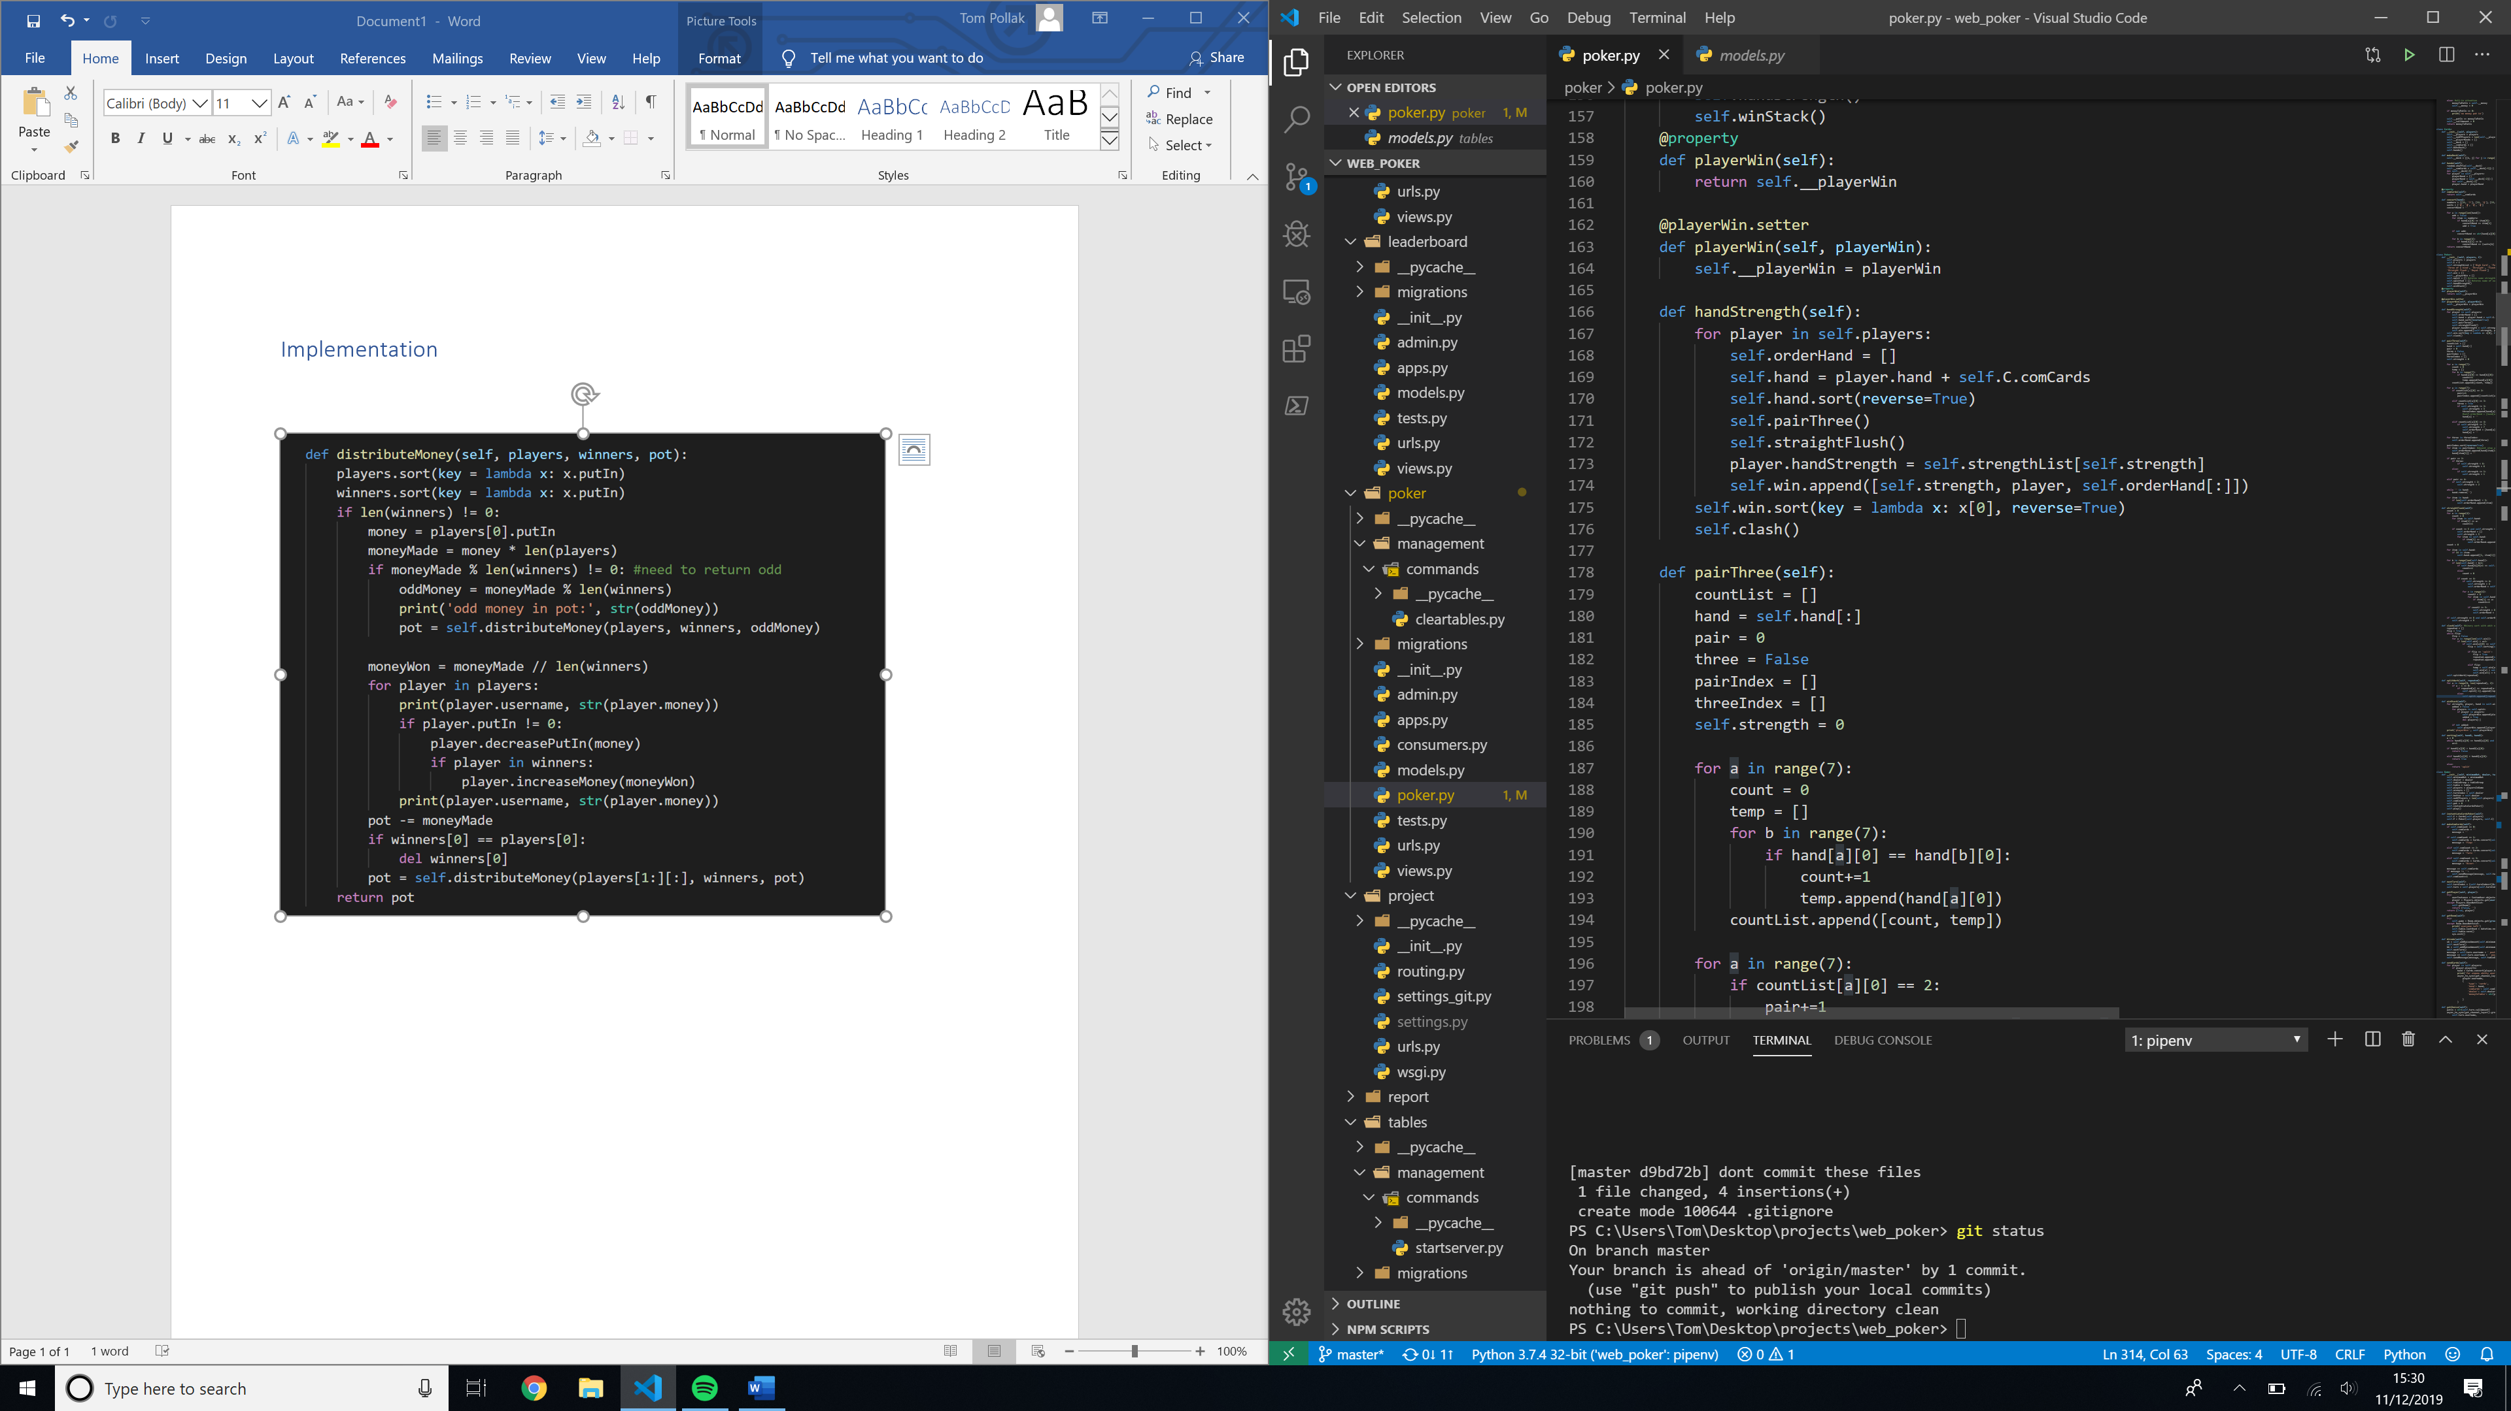

## Anonymous function



## Binary Sort

If two players have the same hand strength, the program needs to sort the cards by the ‘strength’ of the card e.g. Ace > King. The cards are already ordered so the cards that make hand strength are at the front of the hand, e.g. the 10 pair comes before the Ace.

A binary sort is used to sort the hands as there will be at most 8 players in the table so the overhead necessary for a merge sort would not be efficient. If two players have exactly the same strength then the two players are appended to the split array in an array.

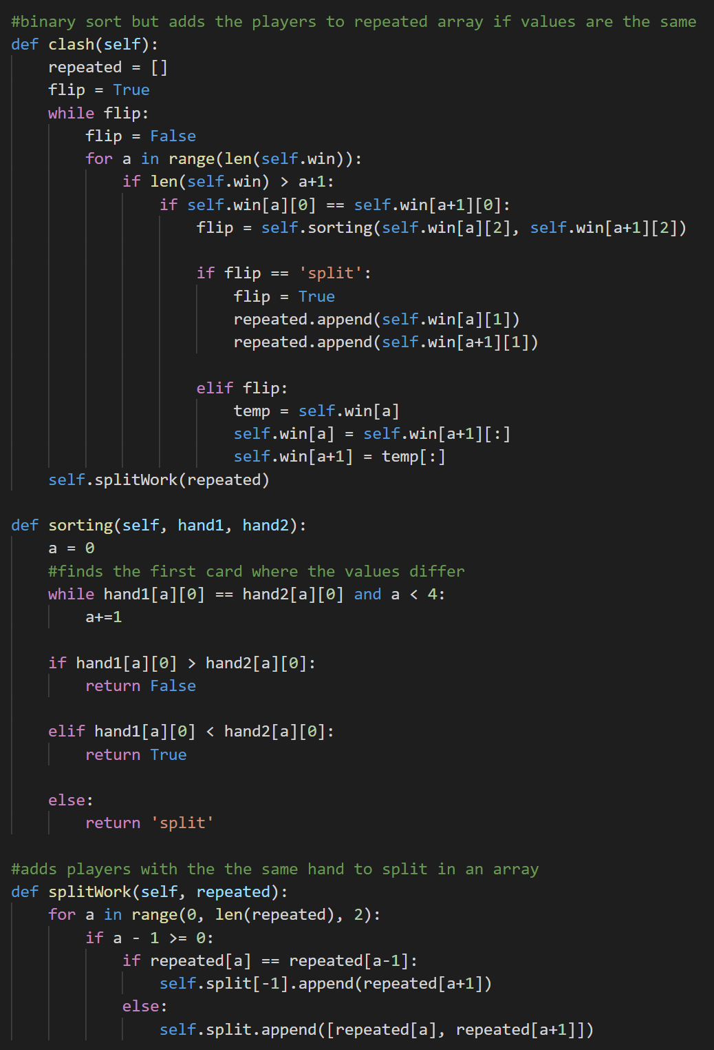

## List operations

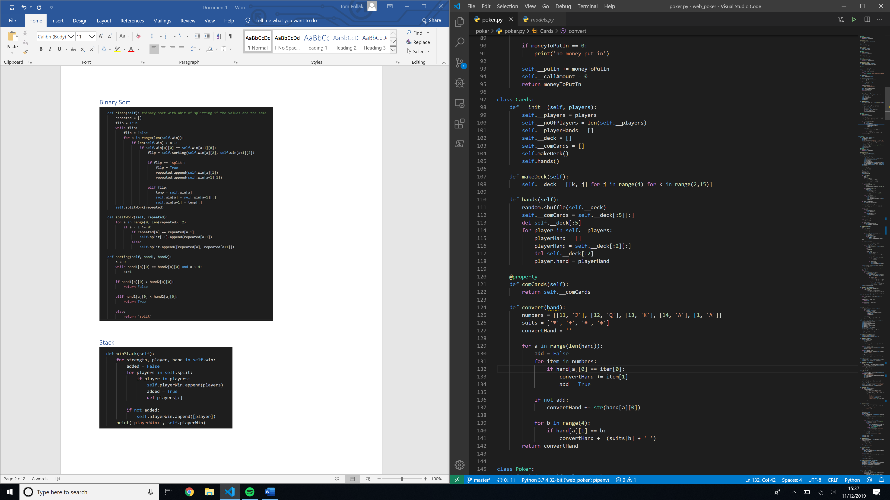

## Queue

### Creating

From the sorted array created by the binary sort, the player object from each hand is appended to the playerWin queue in an array. If the player object is in the split array, i.e. the player has the same strength as another player and so would share the pot if won, the split array is appended to the win queue.

This is why the player object is appended in an array in first part so all the player objects are 2 layers deep. Also includes list operations append and remove.

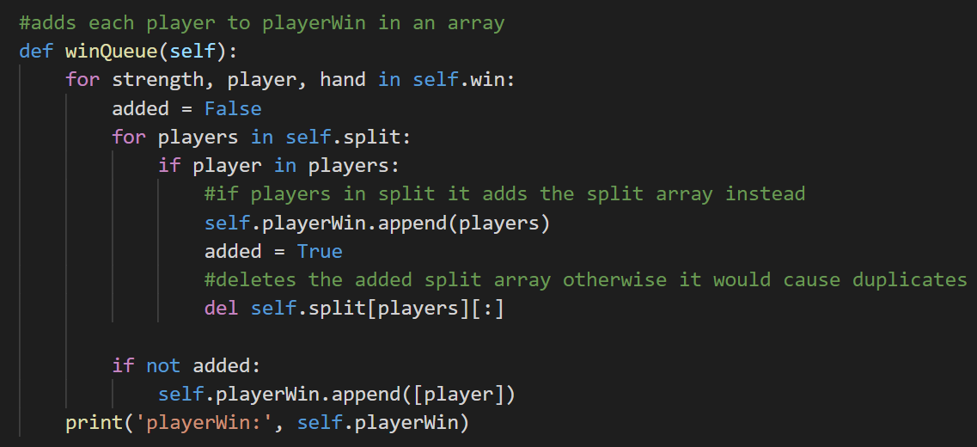

### Using

To distribute the money according to how much money each player has put in the pot, the program de-queues the first array in the playerWin queue and passes all the players in the array that haven’t folded to the distributeMoney method.

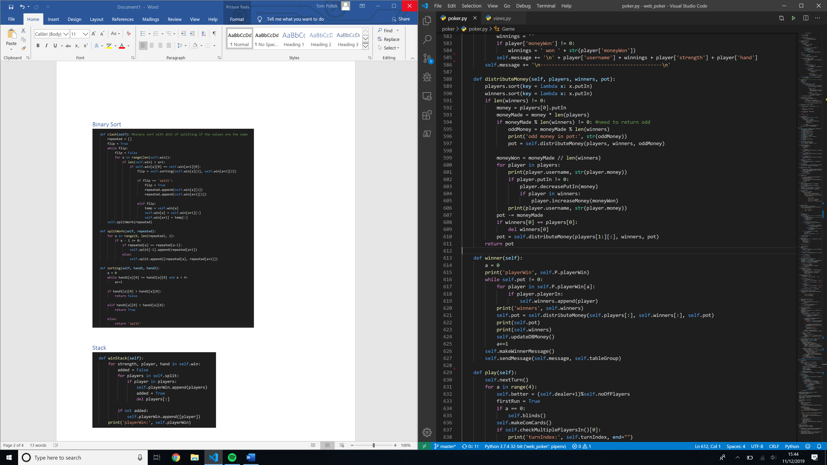

## Recursive Function

The recursive function sorts the players by the amount of money each player has put in. It calculates the amount of money each winner is due based on the number of winners and players in the array and decreases the amount each player has put in.

With each iteration it calls the function with one less player and deletes winners that have been de-queued from the players array. In certain situations, the total pot cannot be divided equally by the number of players.

The extra chips must be shared out as equally as possible, so the program divides the money by all the winners except the one furthest to the dealers right.

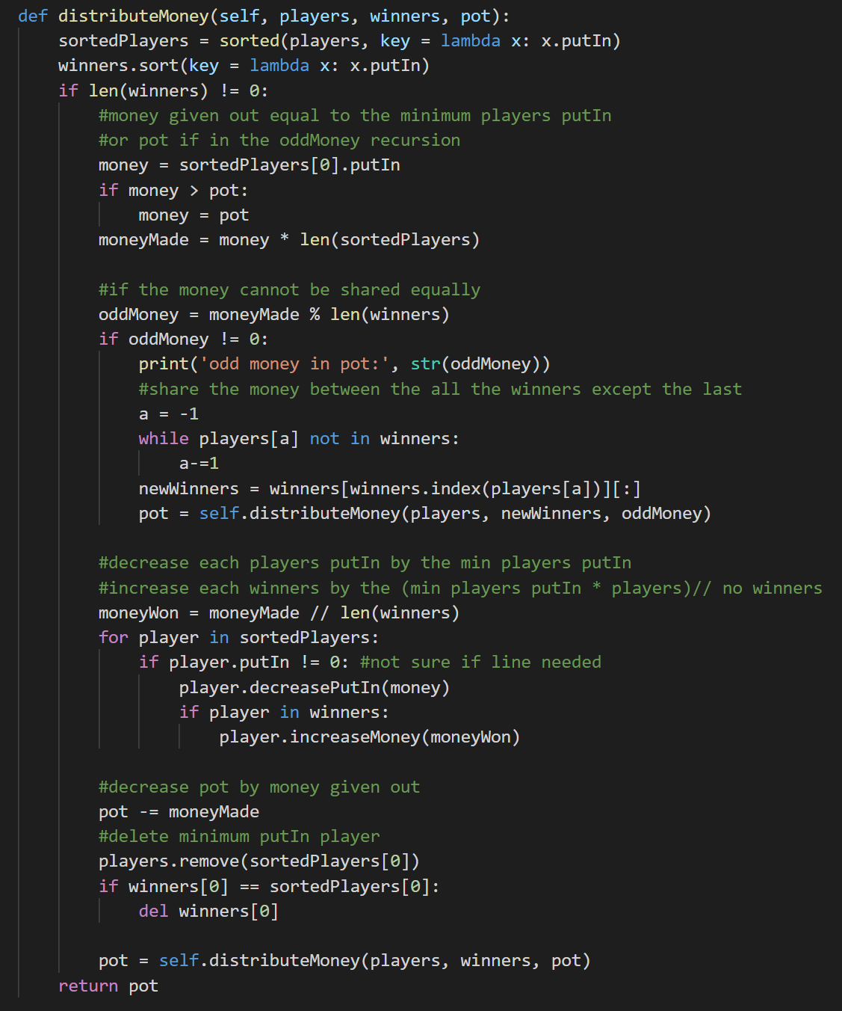

## Do winner message

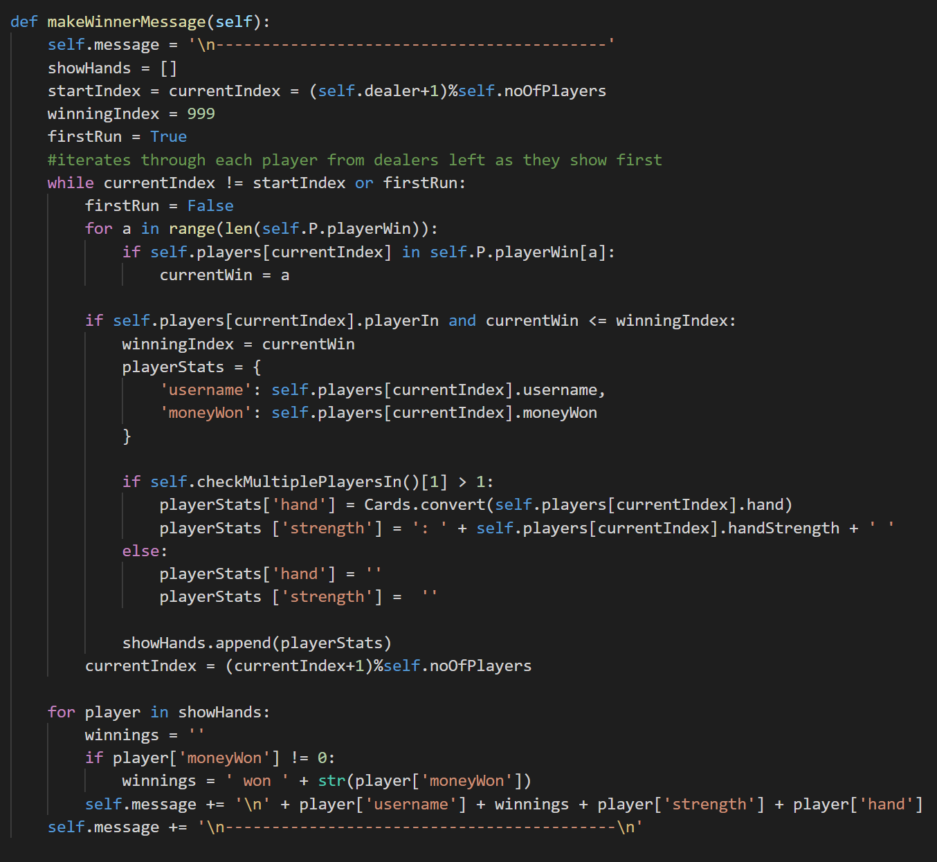

## DB Objects

In Django, DB records can be modelled as Python objects. Each DB table is represented as its own class.

### Creating DB Objects

Each variable represents a row of the table. The **Table** object can also reference the **Room** object because there’s a one-to-one relationship between the **Table** and the **Room**, as instantiated in the **Room** object.

DB classes can also contain methods that can be run on the data in the table. These can be run by calling the method from a **Table** object as with normal OOP. For example, the **Room** table contains the players in a table. However, the **Room** object only exists while players are in the table. So, if the table has no players in it, trying to get the number of players in the table will return an error.

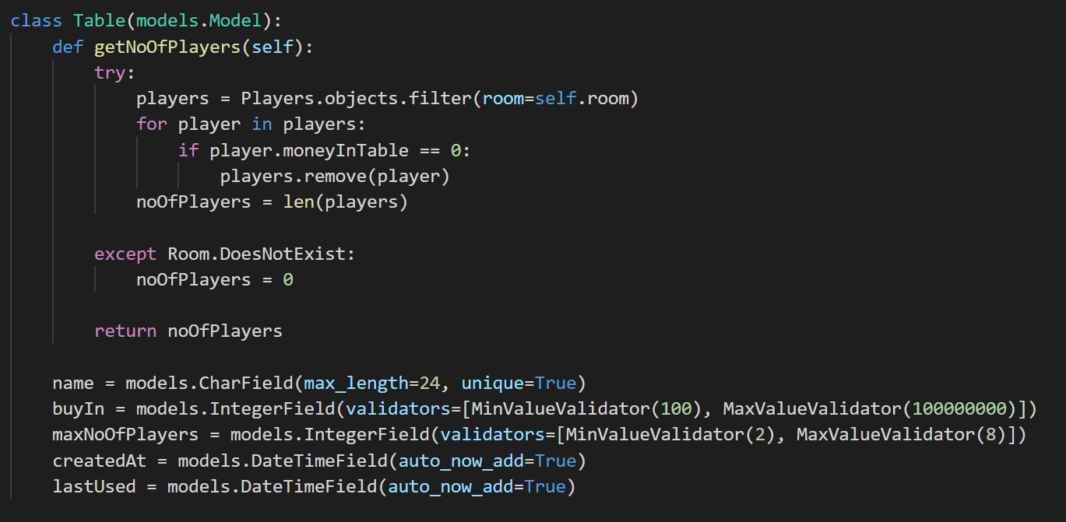

### Instantiating DB objects and records, getting DB objects

The function gets the player’s user data from the database using the player’s username. Getting an object is similar to WHERE in SQL syntax, however must only return one DB object.

It then creates a new DB record using the **CustomUser** object and the **Room** object. This is stored as a one-to-one relationship with **CustomUser** and a foreign key with **Room**.

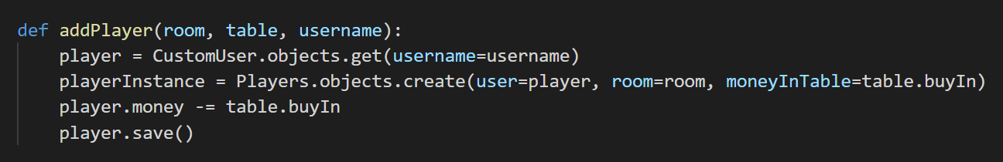

## Threading

### Creating thread

The view function has an @login_required decorator which means that only logged in users can access the function. If the user has the minimum required money to join the table and the table is not full, it starts a daemon poker thread.

A daemon thread runs in the background so the view can return and the program can end to accept more web requests without the daemon thread ending.

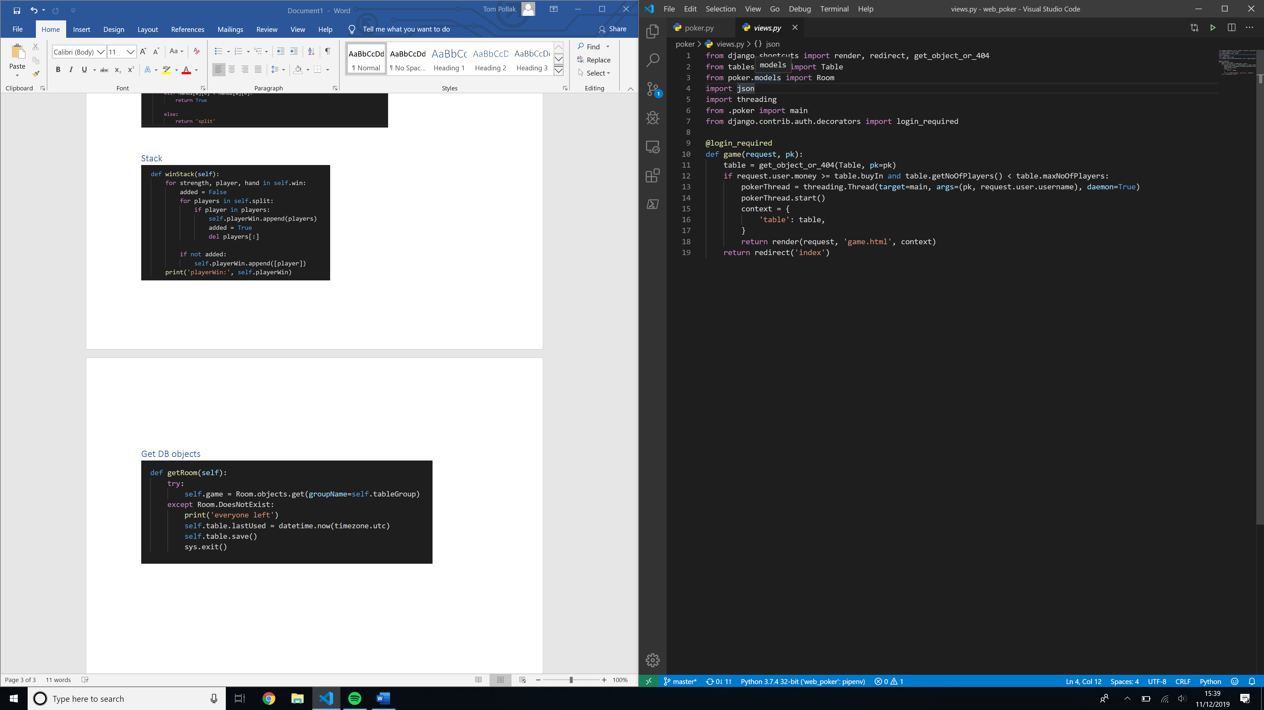

### Thread function

The function checks for an active **Room**. If a room is found, it adds the player and exits. If the **Room** doesn’t exist, it creates a **Room** record and adds a player to the room. It then starts the game.

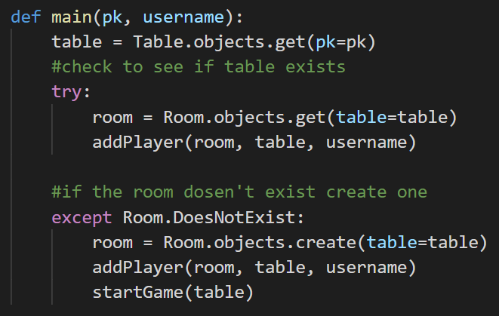

## SQL filter query to get player object array to instantiate OOP

This function runs in an infinite loop starting the next poker round when the previous round finishes.

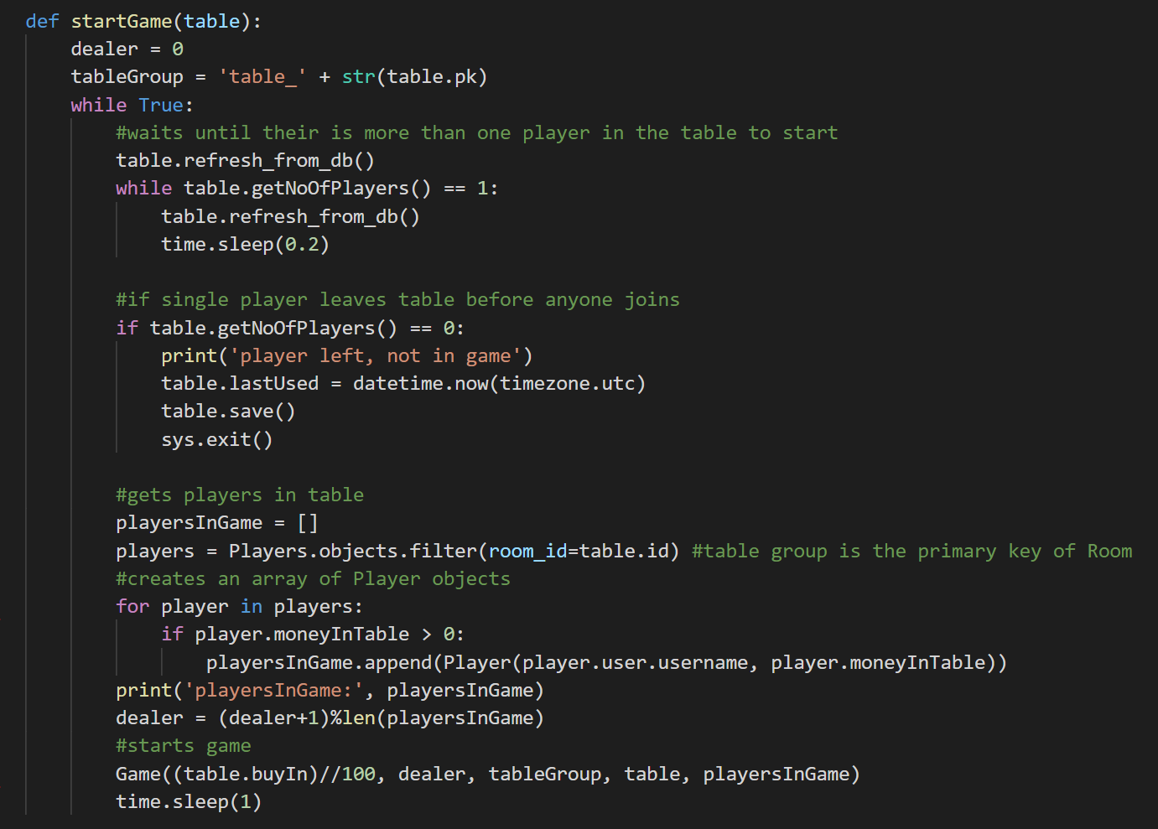

## Synchronous web sockets

### Server-side

#### Connecting

This method adds a player to the table group and creates a unique group to receive their cards.

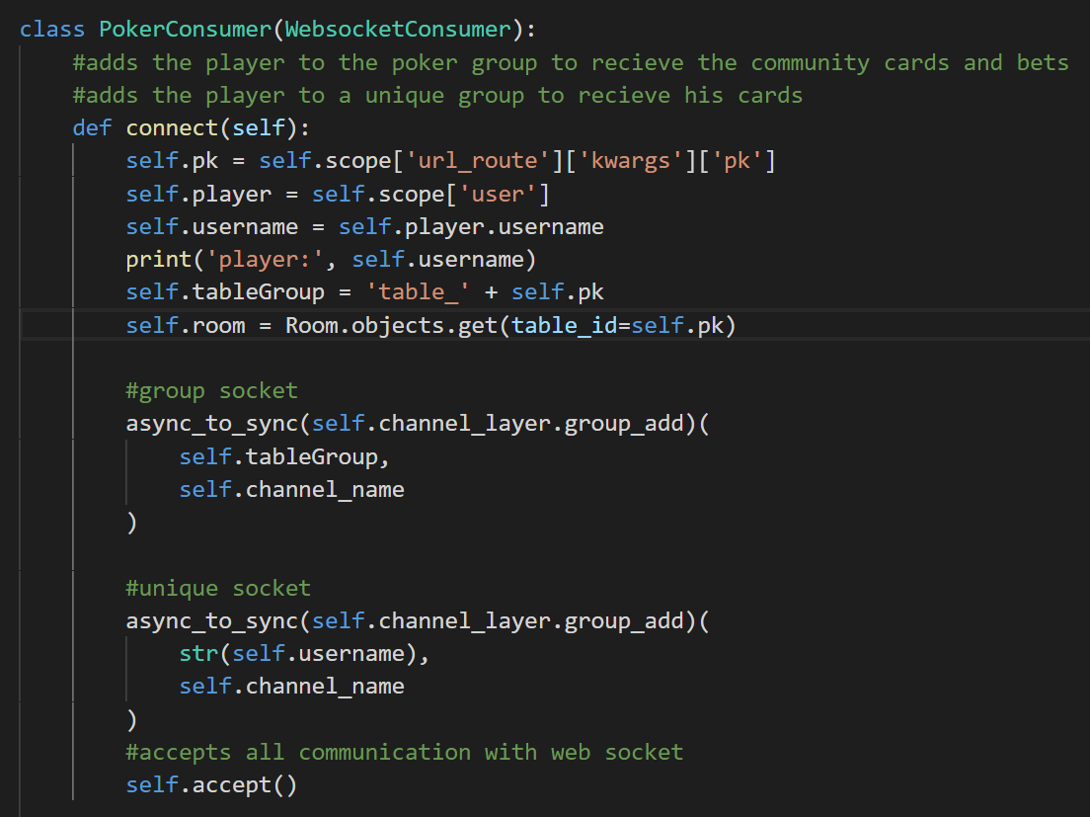

#### Receiving

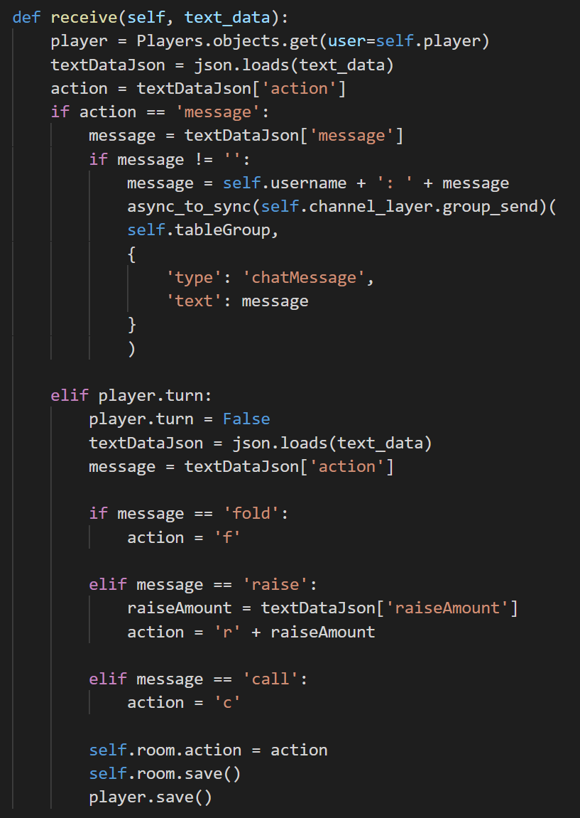

#### Sending

##### Poker method

This method gathers the data for each player to send to the consumer.

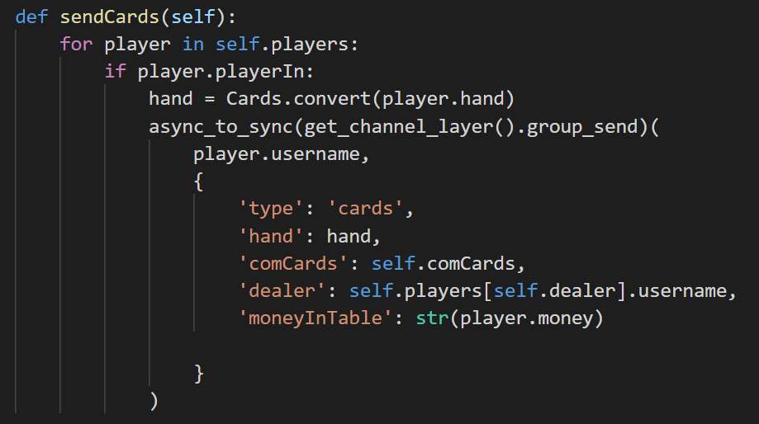

##### Consumer method

This method sends the message to the client.

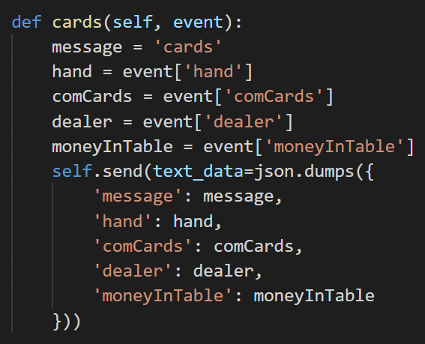

#### Disconnecting

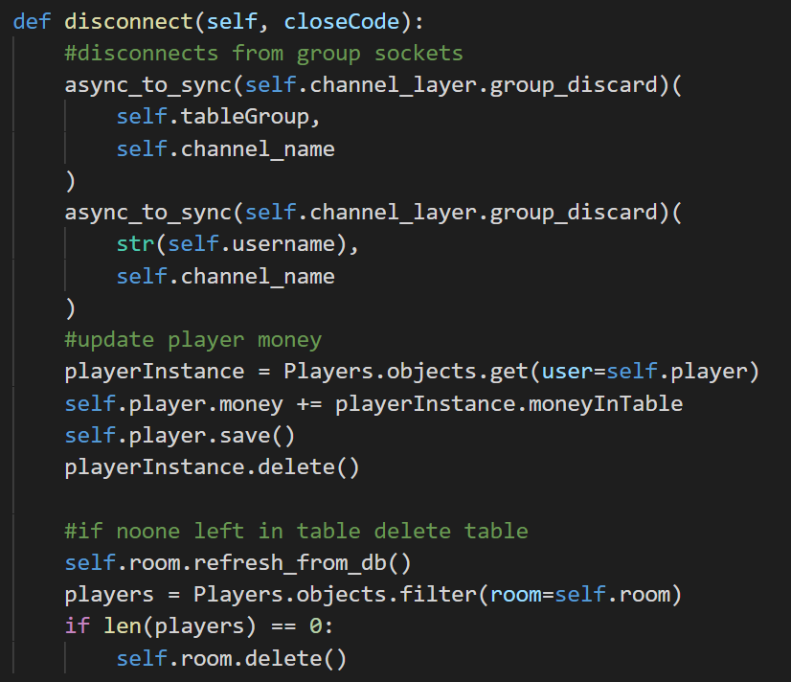

### Client-side JavaScript

#### Connecting

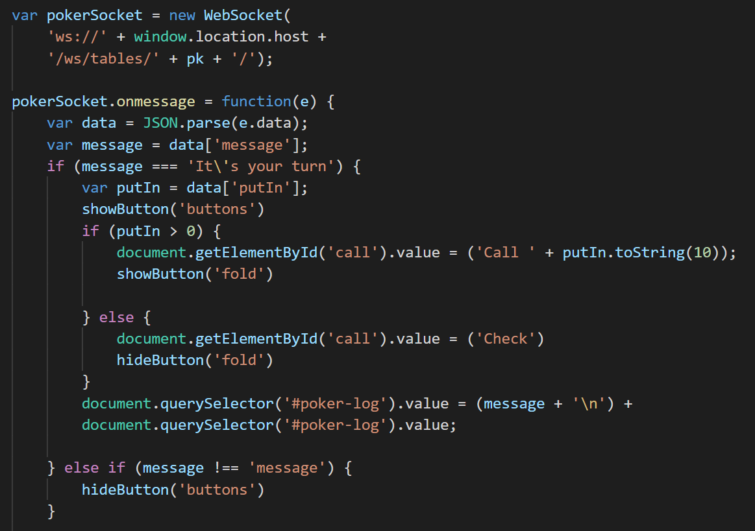

#### Receiving

Part of the receiving function.

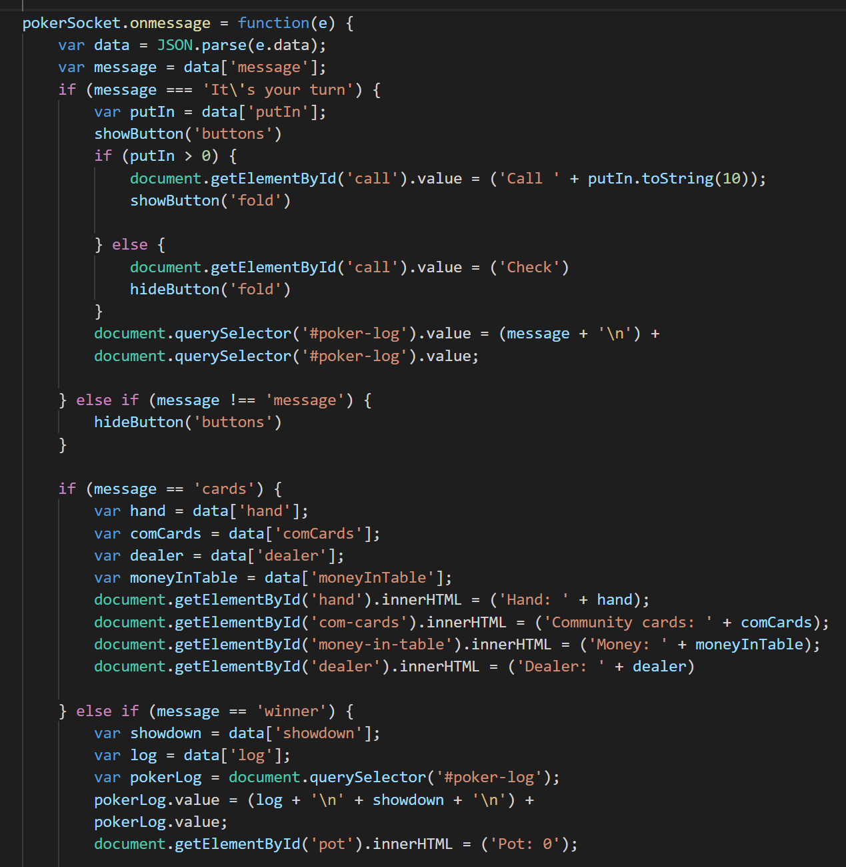

#### Disconnecting

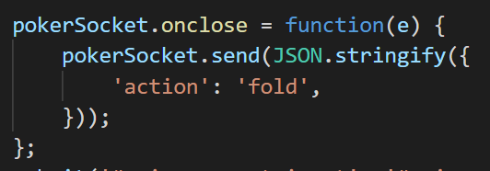

## DB Model

As DB models are Python objects, they can contain Python methods to interact with the data.

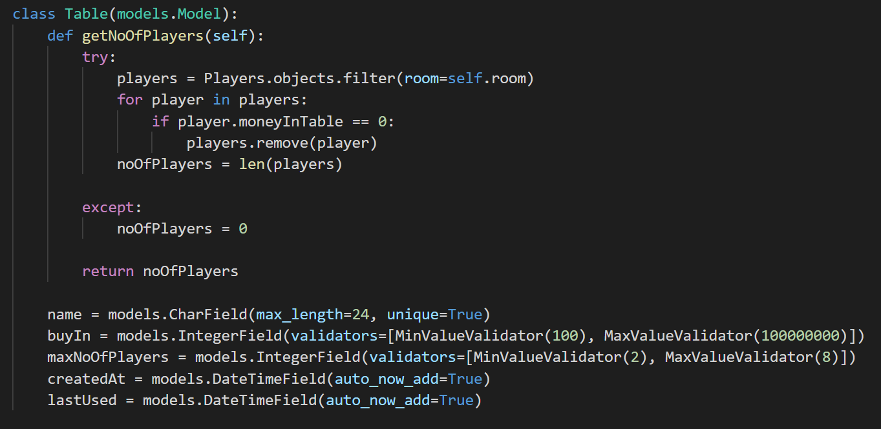

## Regular Expressions and Inheritance

The user model inherits from the default AbstractUser class that comes by default with Django. The AbstractUser class contains user characteristics such as username, password.

The CustomUser class uses polymorphism to overwrite the default username field and regex expressions to check that the username is alphanumeric. The username is used for the players unique socket name and must be alphanumeric.

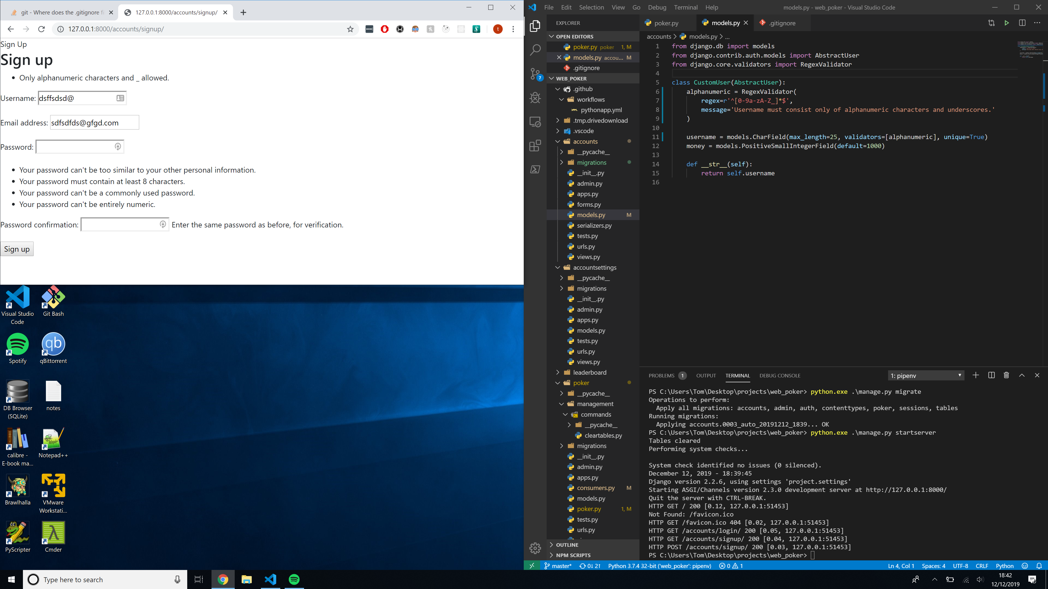

## Exception handling and getting and setting private variables

A property decorator works so that you can use the property function to get the value like a variable and must return a value. It is equivalent to a getter.

A setter function is called when you attempt to set the property function. It verifies that the input is valid and sets the value or raises an exception if not.

### Private variables

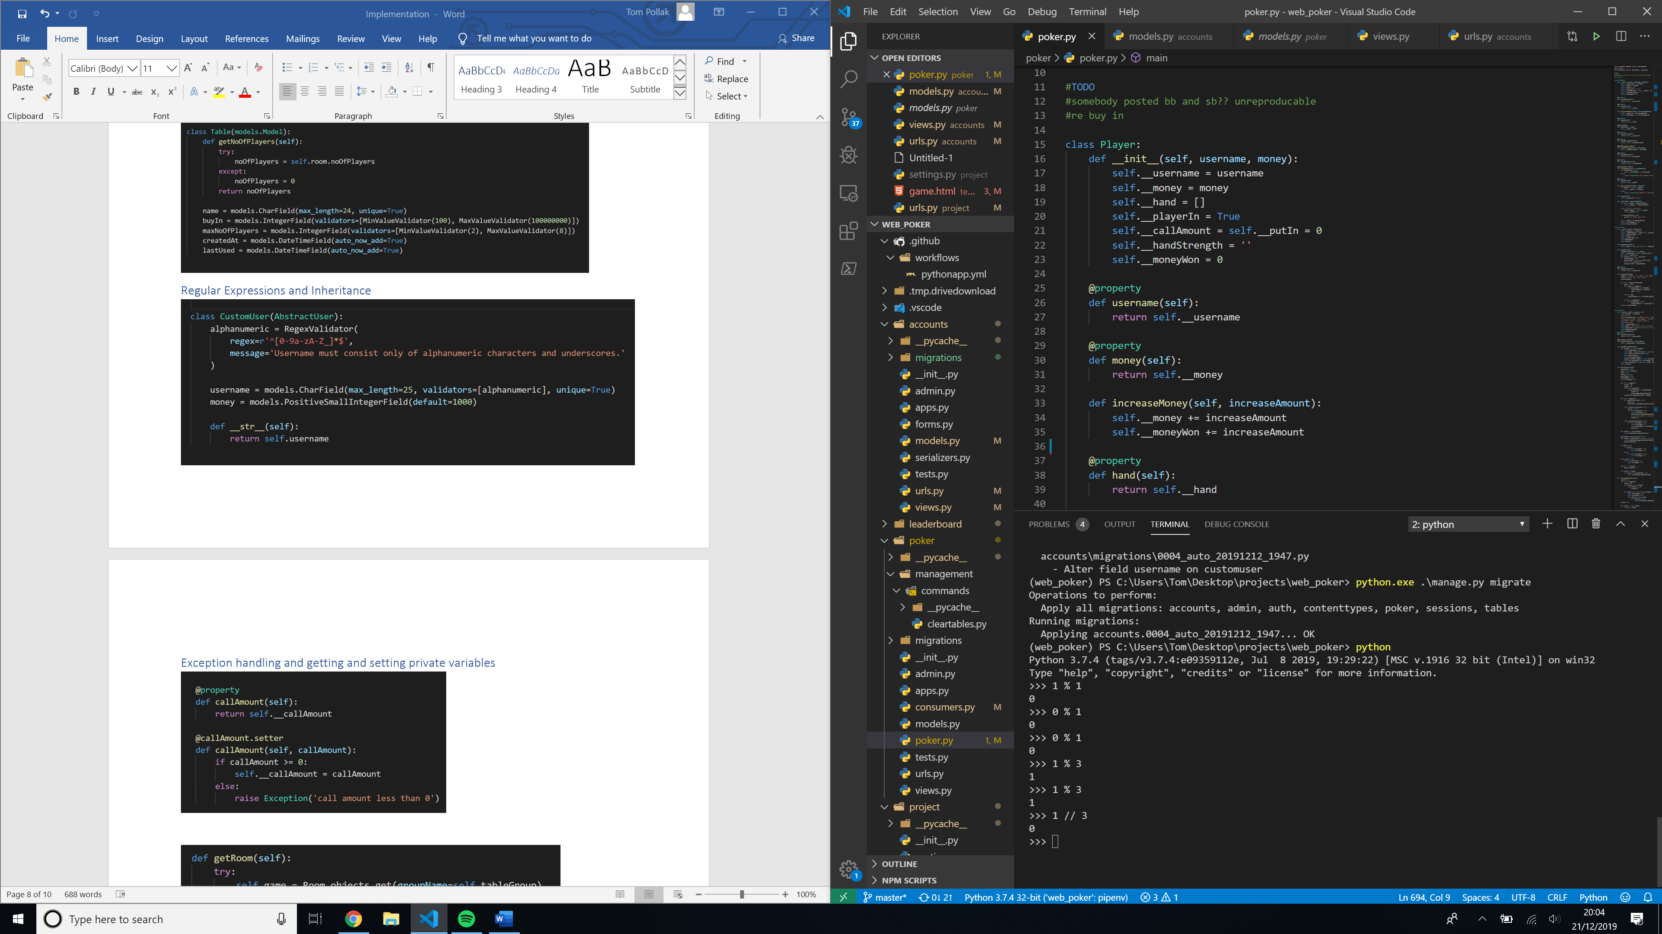

### Exception handling

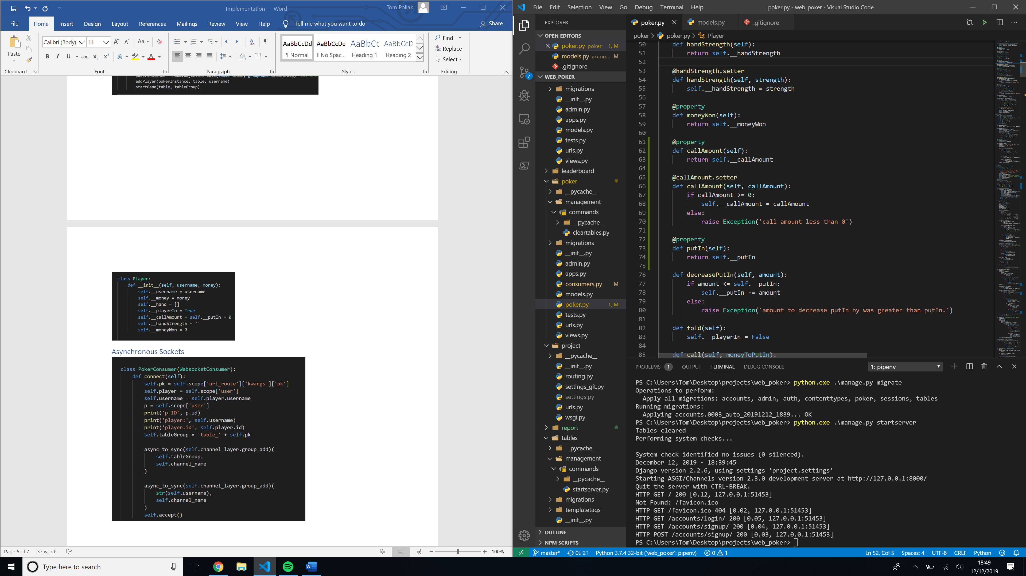

## Web requests

### Server-side scripting

#### Class Based views

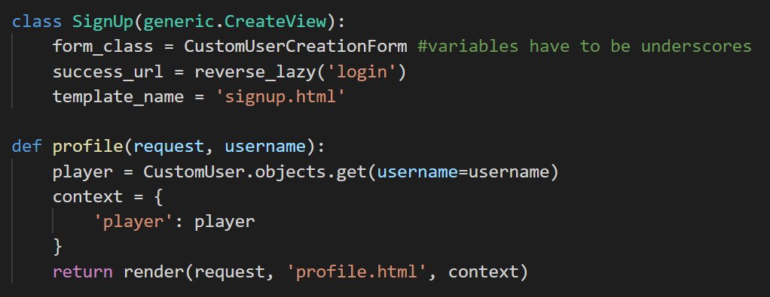

#### Function based view

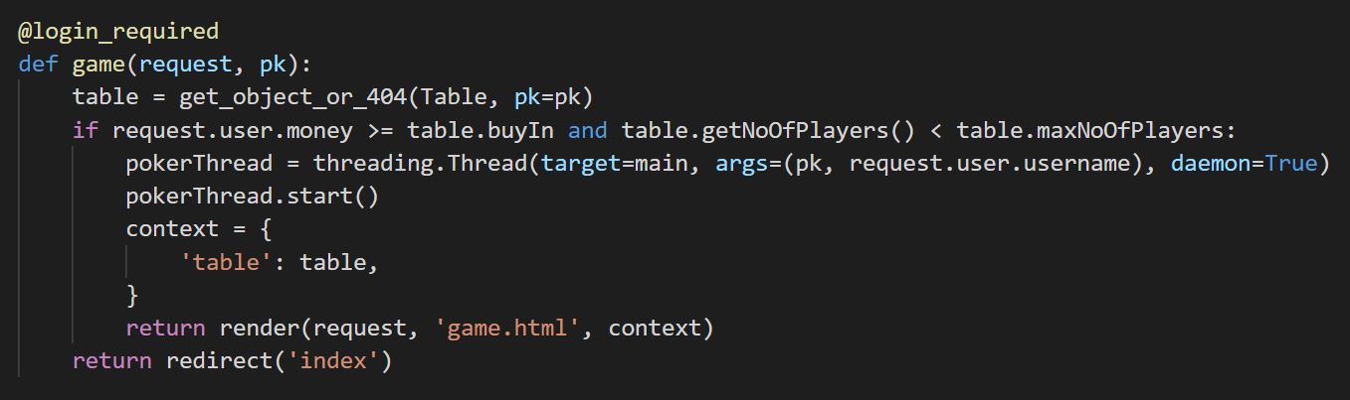

### URL paths

#### HTTP

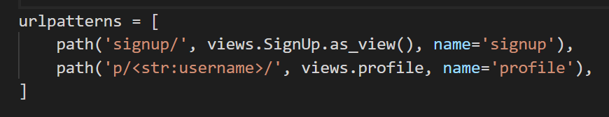

#### Consumer routing for sockets

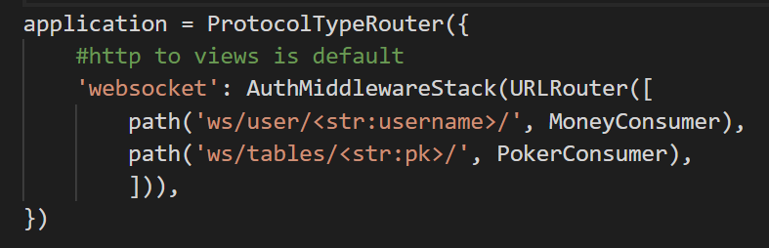

### Handling form POST request and GET request

#### Form Model

The create table function uses a form created using the **Table** model. The form can then be saved directly as a **Table** record in the DB

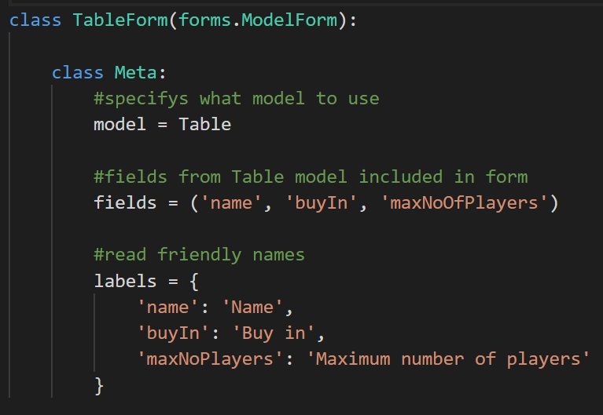

#### Form View

If the form is invalid, the POST request will contain any errors that can be displayed to the user, e.g. password must be more than 8 characters.

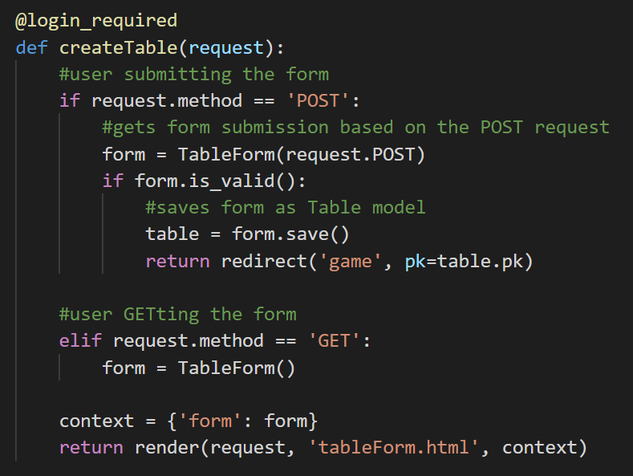

## Serializing DB object into JSON using RESTful API

### Serializing data

To monitor the number of players in each table and the tables available in real time, I used the Django REST framework to serialize the **Table** model into JSON format. This data is passed to the JavaScript using Django channels as JavaScript cannot interpret Python objects.

The name and maxNoOfPlayers come from the **Table** model and the noOfPlayers field comes from the noOfPlayers MethodField. This runs a method that returns a value. The default method it runs is get_<field name>. In get_noOfPlayers it runs the **Table** object method getNoOfPlayers.

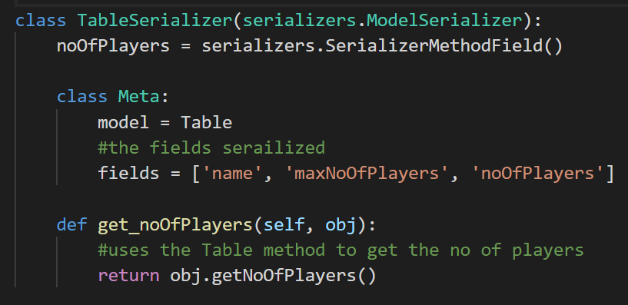

### Creating and using serialized data

This combines the player’s money with the money the player has in the table in order to get the total money. The method then serializes the table and sends the serialized data and money to the client using Django channels.

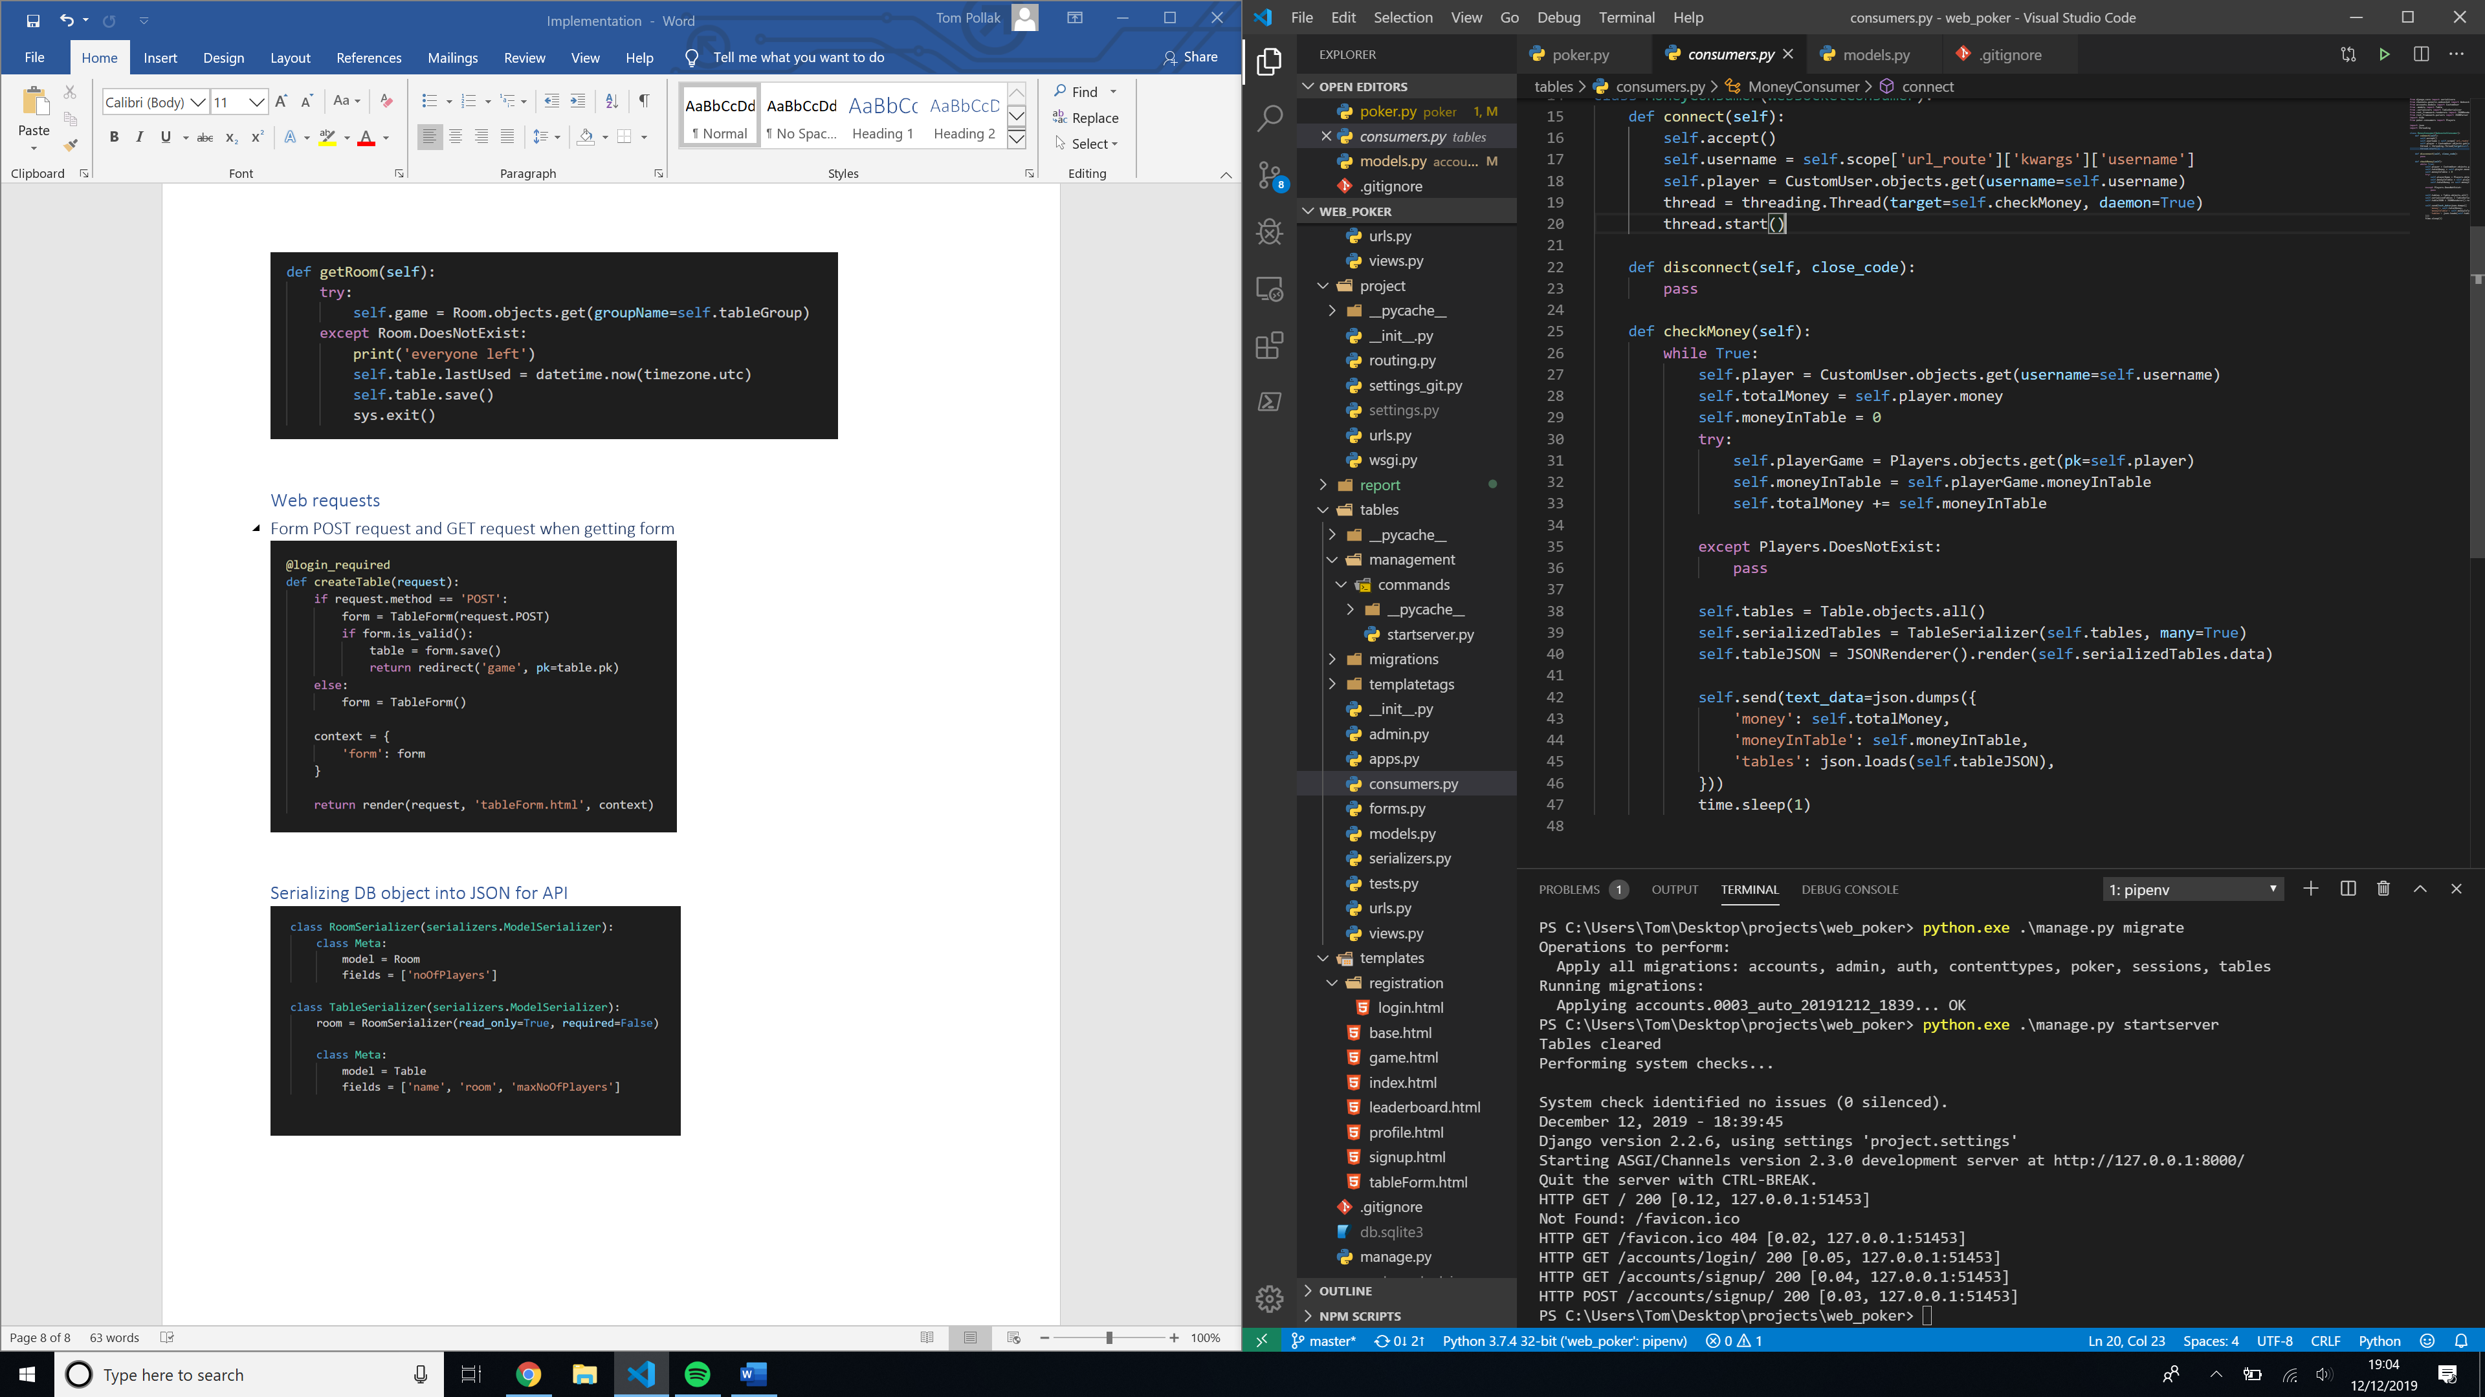

## Reading from file

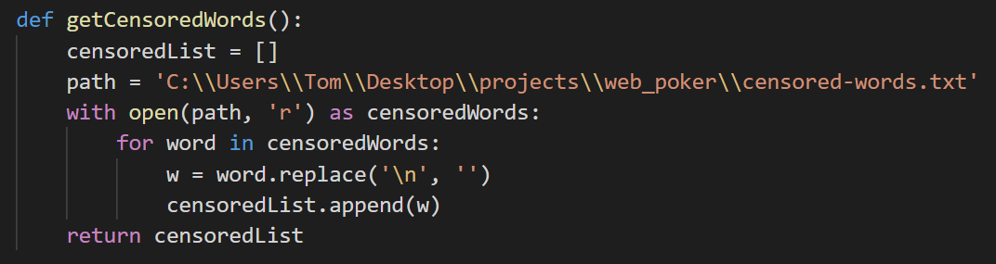

## Scheduling?

I created a custom command called startserver that clears any players currently in tables on start-up and runs a thread to delete tables that have not been used for 15 minutes. It then runs the server.

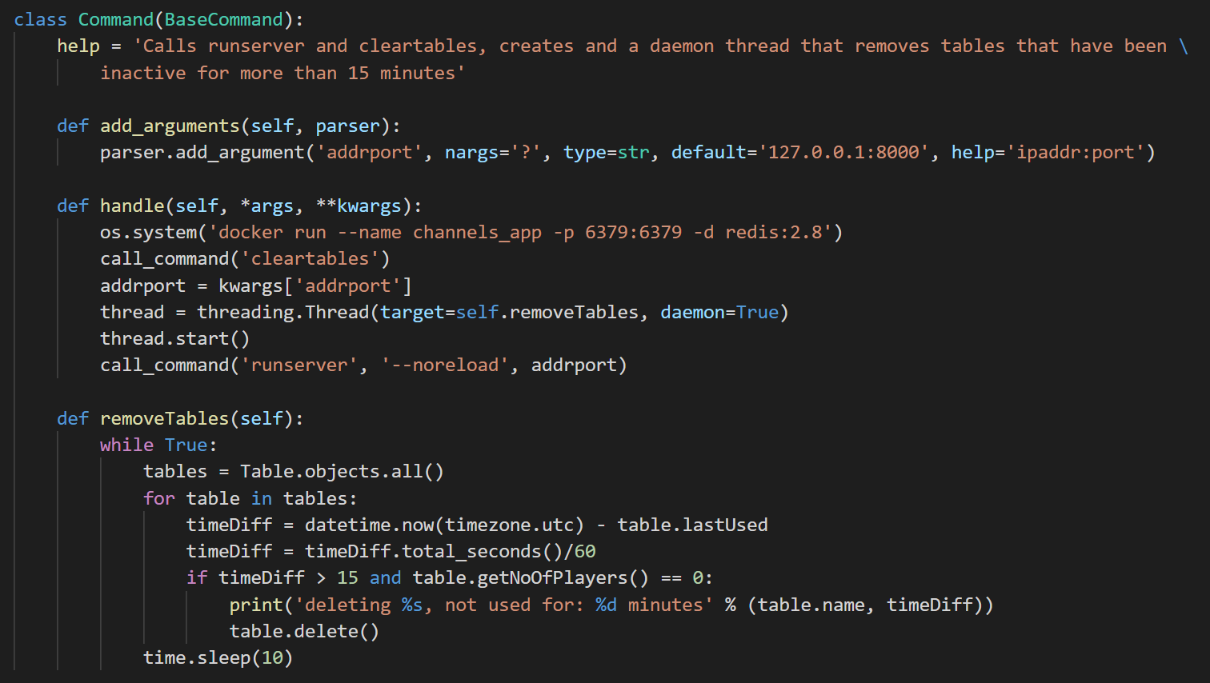

## Complex SQL?

